Importance of Habitat

In order for a species—plant or animal—to occupy a particular area or habitat, its physical surroundings must be appropriate for its survival. All mammals require habitats that provide food and water, and cover for protection from predation and the elements. Suitable mammal habitats also require space for movement.
Environmental factors such as topography, soil type, moisture, and microclimates provide conditions for various vegetation communities, which in turn provide habitat for animals. Over time and under influence of various disturbances, plant communities undergo successional stages—each becoming a habitat to which particular mammals adapt.
Suitable habitat conditions for forest wildlife include forest structures or vegetation elements of tree snags as well as forest floor litter and logs of sufficient quantities. Other determinants of habitat quality include tree height and density of canopy, amount of forest edge and natural openings within the forest, occurrence and distribution of riparian areas and wetlands.
Where pressures exist, some forest mammals that are sensitive to human-induced disturbances become dislocated and eventually extirpated. The southern boreal (Athabasca) region is especially prone to such disturbances because concentrated industrial-resource activities result in forest fragmentation and forest liquidation.

Mammal Identification Resources

Alberta Mammals: An Atlas and Guide. Hugh C. Smith. Edmonton: The Provincial Museum of Alberta, 1993.
Animal Tracks of Alberta. Ian Sheldon and Tamara Eder. Edmonton: Lone Pine Publishing, 2000.
Mammals of Alberta. Don Pattie and Chris Fisher. Edmonton: Lone Pine Publishing, 1999.
The Mammals of Alberta. J. D. Soper. Edmonton: Queen’s Printer, 1964. [Out of print. Available at better used books stores and public libraries.]
Mammals of Canada. A. W. F. Banfield. Toronto: University of Toronto Press, 1974.
Code of Responsible
Wildlife Viewing

Wildlife viewing demands courtesy and common sense including respect for the animals and their habitats, knowledge of local regulations, and consideration for private property and the activities of others.

Ethics for Wildlife Viewing
Be considerate of wildlife
- Observe animals from a distance that they consider safe. Use binoculars, telescopes, and cameras with telephoto lenses for close-up views.
- Avoid nesting areas and respect resting periods.
- Try not to surprise, and never chase, wildlife.

Control pets
- Pets, especially dogs, can be harmful and hinder viewing opportunities.
- Pets should be under control always, or left at home or in the vehicle.

Do not approach baby animals
- Your actions may scare away the parents and expose the young to predators.
- Touching young animals may lead their parents to reject them.

Be considerate of the environment
- Leave viewing sites undamaged by your visit.

Be considerate of others
- Avoid disrupting the wildlife viewing activities of others.
Sources
Developing Your Wildlife Viewing Site, p. 34. Alberta Environmental Protection Publication no. 504.
June 1993.
Inventory and Monitoring of Wildlife Habitat,
pp. 80-83. U.S. Department of Interior, Bureau of Land Management. September 1986.
Athabasca Region
Wildlife Viewing Areas

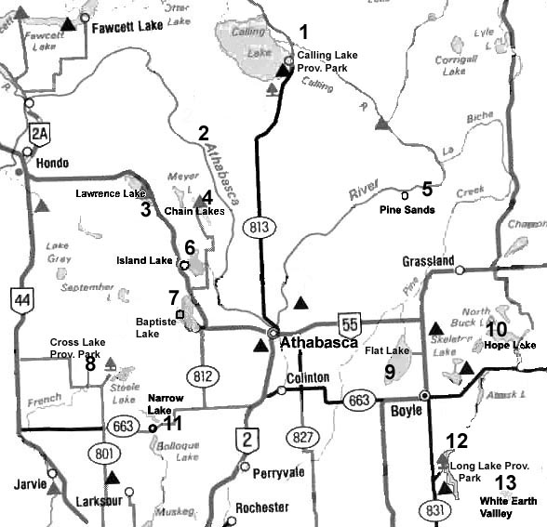
TWP 74
₁₄

TWP 62

- Calling Lake Provincial Park
- Athabasca River
- Lawrence Lake Campground
- Chain Lakes Campground
- Pine Sands Natural Area
- Island Lake Campground
- Baptiste Lake Public Beach
- Cross Lake Provincial Park
- Flat Lake (proposed viewing area)
- Hope Lake Campground
- Narrow Lake Campground
- Long Lake Provincial Park
- White Earth Valley Natural Area
- Fawcett Lake Campground

Mammals of the Athabasca Region is sponsored by Crooked Creek Conservancy Society of Athabasca, with assistance provided by Friends of the Athabasca Environmental Association, Athabasca University, and an Alberta Community Lottery Board grant. © 2002
Mammals
of the Athabasca Region
Mammals of the Athabasca Region is a general guide to mammals you may see in the area. The 55 species listed have all been sighted by local residents, naturalists, or professional zoologists. Depending on the season, you may see mammals native to the region or seasonal visitors. Distribution and abundance vary according to the season and from year to year.

Landscapes of the Athabasca Region vary from flat to rolling terrain formed by the Laurentide glacier and its retreat some 12,000 years ago. Hills, valleys, lakes, and watercourses, including the Athabasca River, reveal their glacial origins.

The Athabasca Region lies within the circumpolar Boreal (Taiga) Forest. Mature upland forests are dominated by white spruce with some addition of birches and balsam fir. Common shrubs are alders and willows. Ground cover includes mosses and lichens. Following disturbances such as fire, aspens take over. Eventually, they provide the shade that conifers like when they are young. Fruit-bearing shrubs (saskatoons, pin cherries, choke cherries) are common in aspen forests. As the spruce matures, the forest is called a mixedwood forest. As the forest ages, aspens decline leaving a nearly pure spruce forest.

On light sandy soils, jack pines are the dominant trees. Pine forests tend to be open without thick shrubs, and with only a scanty ground cover of plants such as bearberry and cranberry. In acidic peatlands, black spruce is the most common tree, with bog birch and Labrador tea common shrubs; tamarack in nutrient rich fens and bogs.

Mammals of the Athabasca Region will be updated from time to time. Please send any comments to
Mammals of Athabasca
Crooked Creek Conservancy Society of Athabasca
P.O. Box 2072 • Athabasca AB • T9S 2B6 • Canada

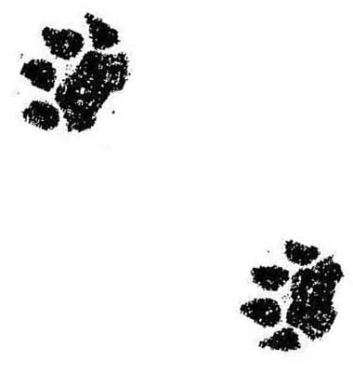  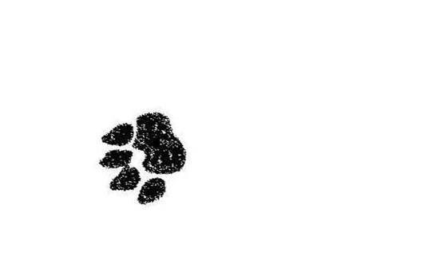 | 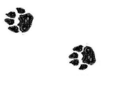 | 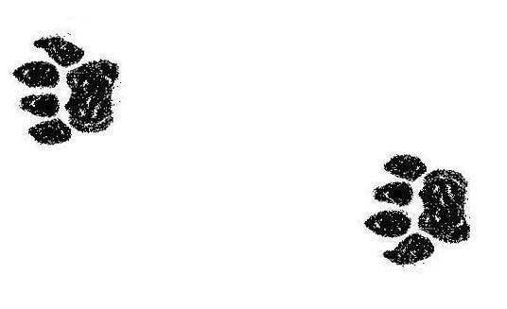 | 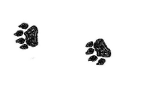 | 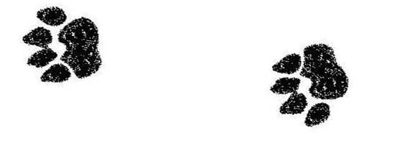 | 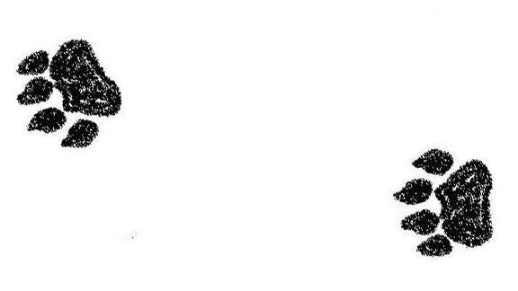 |  |  |  |  |  | 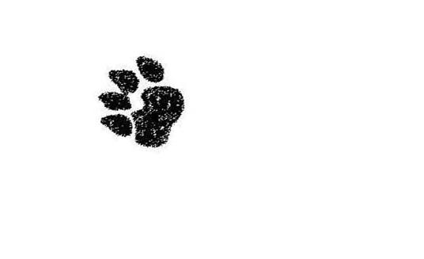

Mammal |  | Relative  Abundance |  |  |  |  | Status / Rank |  |  | Where Found / Comments | When Active
Order Insectivora Family Soricidae
Masked Shrew (Sorex cinereus) |  |  |  |  | C |  | ●● |  | Found in a variety of habitats; A E G |  |  
Dusky Shrew (Sorex monticolus) |  |  |  |  | C |  | ●● |  | Likes dense cover; bogs and meadows; A E G / con |  |  
Water Shrew (Sorex palustris) |  |  |  |  | p/C |  | ●● |  | Always close to water or in water; B E |  |  
Arctic Shrew (Sorex arcticus) |  |  |  |  | C |  | ●● |  | Moist regions of forests to spruce bogs; A E G |  |  
Pygmy Shrew (Sorex hoyi) |  |  |  |  | U |  | ●● |  | Variety of habitats, prefers dry uplands; A |  |  
Order Chiroptera Family Vespertilionidae
Little Brown Bat (Myotis lucifugus) |  |  |  |  | C |  | ●● |  | Old buildings near trees and water; B C E |  | ✰ ☑
Silver-haired Bat (Lasionycteris noctivagans) |  |  |  |  | p/C |  | ●● |  | Woodpecker holes; behind loose bark; 4 / C |  | ✰ ☑
Big Brown Bat (Eptesicus fuscus) |  |  |  |  | p/C |  | ●● |  | Old buildings; also caves and crevices, forests; 4 / C |  | ✰ ☑
Hoary Bat (Lasiurus cinereus) |  |  |  |  | C |  | ●● |  | Coniferous and deciduous forests, true arboreal bat; only females in Alberta; 4 / B C |  | ✰ ☑
Northern Long-eared Bat (Myotis septentrionalis) • |  |  |  |  | p/U |  | ●●●● |  | Mixed and coniferous forests;  4 / C E |  | ✰ ☑
Order Lagomorpha Family Leporidae
Snowshoe Hare (Lepus americanus) [10 year cycle] |  |  |  |  | C |  | ●● |  | Shrubby areas and forests; bogs in winter; 2, 3 / G / mix |  | 
White-tailed Jack Rabbit (Lepus townsendii) ٱ h |  |  |  |  | R |  | ●● |  | Mostly prairie, open parkland; not documented north of TWP 62; 1 |  | 
Order Rodentia Family Sciuridae
Least Chipmunk (Tamias minimus) |  |  |  |  | p/C |  | ●● |  | Forests, woods, wood piles, rock piles; A B E / mix |  | ☼ 
Woodchuck (Marmota monax) |  |  |  |  | U |  | ●● |  | River valleys, rock piles, under buildings; 1 / B |  | ☼ 
Richardson Ground Squirrel (Spermophilus richardsonii) ٱ |  |  |  |  | C* |  | ●● |  | Clearings, fields with coarse textured soils; 1 / F |  | ☼ 
Thirteen-lined Ground Squirrel ٱ  (Spermophilus tridecemlineatus) |  |  |  |  | p/U |  | ● |  | Clearings, fields with coarse textured soils, inhabits agricultural areas near TWP 62; 1, 2 / F |  | ☼ 
Franklin Ground Squirrel (Spermophilus franklinii) |  |  |  |  | U |  | ● |  | Aspen forest edges; near water; B F / dec |  | ☼ 
Red Squirrel (Tamiasciurus hudsonicus) |  |  |  |  | C |  | ●● |  | Coniferous forests; 4 / D / con |  | 
Northern Flying Squirrel (Glaucomys sabrinus) |  |  |  |  | p/U |  | ●● |  | Coniferous and mixed forests; C. where habitat suitable; 4 / mix |  | ✰
Family Geomyidae
Northern Pocket Gopher (Thomomys talpoides) ٱ |  |  |  |  | C* |  | ●● |  | Roadside earth mounds; C. where habitat suitable; 1 / F |  | ⧫ 
Family Castoridae
Beaver (Castor canadensis) |  |  |  |  | C |  | ●● |  | Banks of creeks, lakes, major rivers; E / dec |  | 
Family Cricetidae
Deer Mouse (Peromyscus maniculatus) |  |  |  |  | C |  | ●● |  | Most everywhere (including occupied buildings), except bogs, muskegs |  |  
Southern Red-backed Vole (Clethrionomys gapperi) |  |  |  |  | C |  | ●● |  | Throughout boreal forests including bogs; 3, 4 / A |  |  
Heather Vole (Phenacomys intermedius) |  |  |  |  | U |  | ●● |  | Boreal forests, variety of habitats; A B / con |  |  
Meadow Vole (Microtus pennsylvanicus) |  |  |  |  | C |  | ●● |  | Meadows and hay fields; scarce in forests; 1 / B E |  |  
Taiga Vole (Microtus xanthognathus) • h |  |  |  |  | R |  | ● |  | Along Athabasca River; last caught in 1904; upland boreal forest; mix |  | ?
Muskrat (Ondatra zibethicus) |  |  |  |  | C |  | ●● |  | Sloughs, small lakes, marshes; E |  | 
Northern Bog Lemming (Synaptomys borealis) |  |  |  |  | R |  | ●● |  | Boreal forest wet meadows and bogs; G |  |  
Family Muridae
House Mouse (Mus musculus) |  |  |  |  | C |  | E / A |  | Around and inside buildings` |  | 
Meadow Jumping Mouse (Zapus hudsonius) |  |  |  |  | C |  | ●● |  | Moist meadows near streams and bogs; 1, 2 / E |  | ☼ 
Western Jumping Mouse (Zapus princeps) |  |  |  |  | C |  | ●● |  | Moist meadows near streams and bogs; 1, 2 / E |  | ☼ 

Family Erethizontidae
Common Porcupine (Erethizon dorsatum) |  |  |  |  | p/C |  | ●● |  | Forests, primarily spruce and pine stands, in variety of habitats;  3, 4 / con |  | 

Order Carnivora Family Canidae
Coyote (Canis latrans) |  |  |  |  | C |  | ●● |  | Forests, farm lands, along roads, variety of habitats; B |  | 
Gray Wolf (Canis lupus) • |  |  |  |  | U |  | ●● |  | Throughout boreal forest, rare in southern boreal |  | 
Red Fox (Vulpes vulpes) |  |  |  |  | p/C |  | ●● |  | Forests, grasslands, along roads; 2 / B |  | 
Mammal | Relative  Abundance |  |  | Status / Rank |  |  |  | Where Found / Comments |  |  | When Active

Family Ursidae
Black Bear (Ursus americanus) • |  |  | C | ●● |  | Boreal forest; clearings; 4 / A B E |  |  |  |  | ☼ 
Grizzly Bear (Ursus arctos) • h |  |  | R | ●●●● |  | Clearings; coniferous or mixed forest; may be stragglers northwest of TWP 73;  A B E |  |  |  |  | ☼ 
Common Raccoon (Procyon lotor) h |  |  | R | ●● |  | Treed areas near streams, lakes, ponds; E |  |  |  |  | ☼ 

Family Mustelidae
Long-tailed Weasel (Mustela frenata) |  |  | R | ●●●● |  | Clearings; open forest; 1, 2 / B |  |  |  |  | 
Short-tailed Weasel / Ermine (Mustela erminea) |  |  | p/C | ●● |  | Mixed and coniferous forests |  |  |  |  | 
Least Weasel (Mustela nivalis) |  |  | U | ●● |  | Open forest clearings, variety of habitat |  |  |  |  | 
Mink (Mustela vison) |  |  | C | ●● |  | Close to water; lakes and rivers, meandering streams; E |  |  |  |  | 
American Marten (Martes americana) • |  |  | p/U | ●● |  | Old coniferous forest; 4 / A C D / con |  |  |  |  | 
Fisher (Martes pennanti) • |  |  | U | ●●● |  | Old coniferous forest; 4 / A C D / con |  |  |  |  | 
Wolverine (Gulo gulo) • |  |  | R | ●●●● |  | Throughout boreal forest, wilderness species sensitive to disturbance, population in decline; 4 / E |  |  |  |  | 
American Badger (Taxidea taxus) ٱ |  |  | R | ●●● |  | Open places near ground squirrels; 1 / F |  |  |  |  | ☼ 
Striped Skunk (Mephitis mephitis) |  |  | C | ●● |  | Uplands, shelterbelts, farm buildings, roads; 2 / E / dec |  |  |  |  |  
Northern River Otter (Lutra canadensis) |  |  | U | ●● |  | Wooded rivers, ponds, and lakes; E |  |  |  |  | 
Family Felidae
Cougar (Felis concolor) • |  |  | U | ●●● |  | Forest area where deer abundant |  |  |  |  | 
Canada Lynx (Lynx canadensis) • |  |  | U | ●●● |  | Boreal forest, cyclical, linked with Snowshoe Hare habitat / population;  2, 4 / A G / mix; con -winter |  |  |  |  | 
Order Artiodactyla Family Cervidae
Wapiti / Elk (Cervus elaphus) |  |  | U | ●● |  | Small herd transplanted, clearings, upland forest; 1, 2 / B / dec |  |  |  |  | 
Mule Deer (Odocoileus hemionus) |  |  | C | ●● |  | River valleys, forests; farm fields; 1, 2 / B / dec |  |  |  |  | 
White-tailed Deer (Odocoileus virginianus) |  |  | C | ●● |  | River valleys, mixedwood forests, farm fields; 1, 2 / B / mix |  |  |  |  | 
Moose (Alces alces) |  |  | C | ●● |  | Around lakes, bogs; in mixedwood; 2, 3 / E / dec |  |  |  |  | 
Woodland Caribou (Rangifer tarandus) • h |  |  | R | ●●●●● |  | Old coniferous forest provide lichens food source; site specific; may be stragglers north of TWP 73; 4 / D / con |  |  |  |  | 

Noted Habitat Component: Preference or Requirement |  |  | Relative Abundance |  | When Active
Basic Successional Habitat Types  - grass / forb  - shrub / seedling / sapling  - pole / medium tree  - large tree | Special Habitat Features  - forest litter and logs  - forest edge / openings  - decayed trees and snags  - dense tree canopy  - riparian areas / aquatic  - friable soils  - bog, fen |  | p/ – probable  C – common  U – uncommon  R – rare |  | ✰      ☑        ☼   | nocturnal  hibernate locally  all year  migrate  subnivean  in or near water  winter dormant  snow-free period  underground
 |  |  | Status / Rank |  | ✰      ☑        ☼  
Dominant / Co-dominant Tree Stand Species  con – coniferous  dec – deciduous  mix – mixed coniferous-deciduous stand |  |  | ●  ●●  ●●●  ●●●●  ●●●●●  E / A | undetermined  secure  sensitive  may be at risk  at risk  exotic / alien | ✰      ☑        ☼  
h – hypothetical—unlikely to be encountered in this region
ٱ – inhabits prairie, parkland, and contiguous agricultural breaks
* – populations can vary considerably depending upon locale
• – dependent upon wilderness environment
 |  | Mammals of the Athabasca Region
Relative Abundance – based on numbers relative to suitable habitat for each species within the Athabasca Region.
Populations can vary depending on food supply, prey numbers, disease outbreaks, climatic factors, and disturbances such as fire and logging.
Status / Rank Source
The General Status of Alberta Wild Species. Alberta Environment / Alberta Sustainable Resource Development, 2000.

